LEFT COILPACK RIGHT COILPACK
VIEWED FROM FRONT OF ENGINE

Coil Pack Side | Edis-8 Pin Number | Coilpack Pin Number | EDIS-8 Wire Colour | Coilpack Wire Colour | Driven Plugs
Left | 8 | 1 (A) | Brown White | Brown Green | 1 & 6
Left | 9 | 3 (B) | Brown Orange | Brown Blue | 8 & 5
Right | 11 | 1 (C) | Brown Green | Brown Green | 4 & 7
Right | 12 | 3 (D) | Brown Blue | Brown Blue | 3 & 2

Engine Layout and Firing Order
Top of this list is the front of the engine. No 1 is on left bank (RHS when viewed from front)
1 - 2 1 is firing, 6 is at TDC (in/ex) 8 is firing, 5 is at TDC (in/ex)
3 - 4 4 is firing, 7 is at TDC (in/ex) 3 is firing, 2 is at TDC (in/ex)
5 - 6 6 is firing, 1 is at TDC (in/ex) 5 is firing, 8 is at TDC (in/ex)
7 - 8 7 is firing, 4 is at TDC (in/ex) 2 is firing, 3 is at TDC (in/ex)

Firing order: 1-8-4-3-6-5-7-2
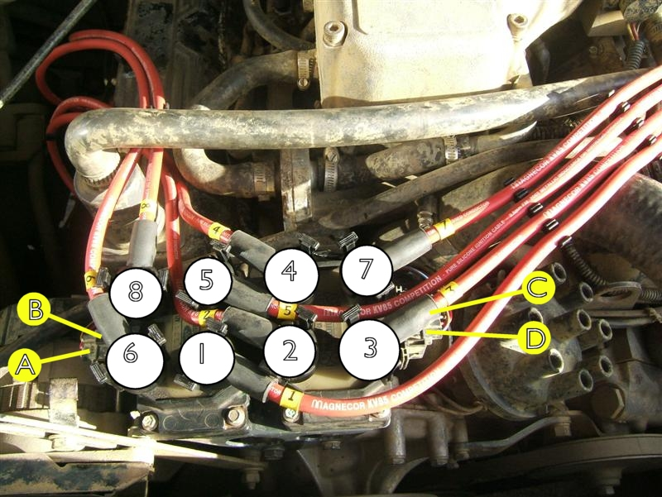

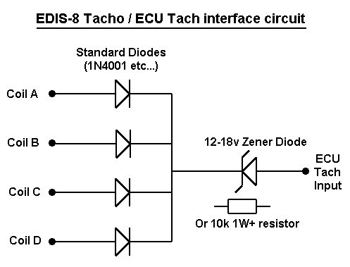

EDIS power switching signal comes from a relay triggered by the coil power (white) lead. This switches a master relay from which ALL EDIS/Megajolt circuits and coilpacks etc, are powered. Similarly ALL circuits are earthed at the same point.

ECU Tach input is through four diodes and a zenner and then is fed back to the coil black/white lead. This means that there is also the standard fitment current limiting resistor still in place.

When using EDIS these wires must be isolated from the original coil and amplifier

